PURPOSE CLAUSES

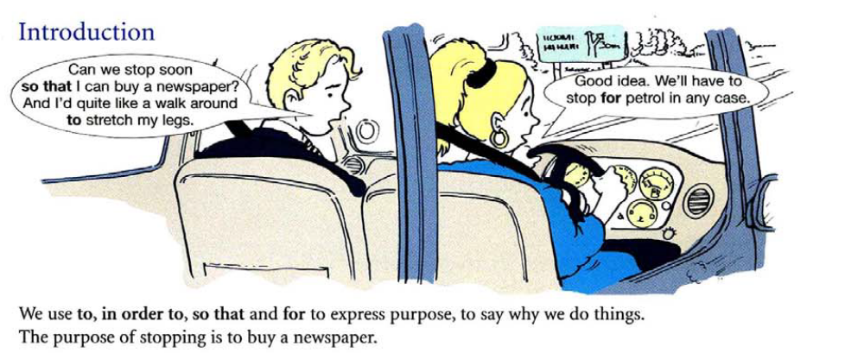

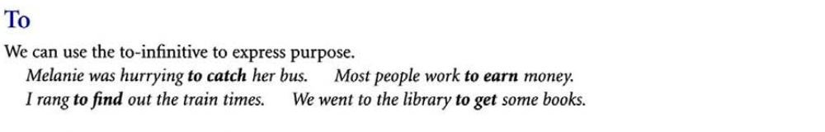

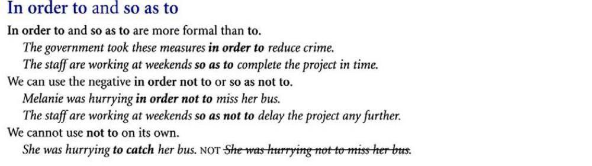

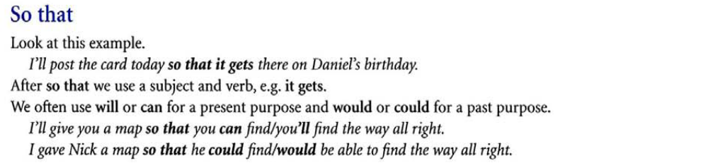

We use so that and in order that to talk about purpose. We often use them with modal verbs (can, would, will, etc.). So that is far more common than in order that, and in order that is more formal:
I’ll go by car so that I can take more luggage.
We left a message with his neighbour so that he would know we’d called.
In order that you can sign the form, please print it out and mail it to this address.
**We often leave out that after so in informal situations:
I’ve made some sandwiches so (that) we can have a snack on the way.
**When referring to the future, we can use the present simple or will/’ll after so that. We usually use the present simple after in order that to talk about the future:
I’ll post the CD today so that you get it by the weekend. (or … so that you will get it …)
We will send you a reminder in order that you arrive on time for your appointment. (or … so that you arrive on time … or … so that you’ll arrive on time …)
I am cutting the cake into many pieces so that / in order that everyone can get a piece.
She wants to study at a good university so that / in order that she can find a good job with a high salary.
We got up early so that / in order that we would not be late for the meeting.

RESULT CLAUSES

-To talk about a result, we use ‘so+clause’: I was tired so I went to bed.

- Therefore, as a result and for this reason have a similar meaning to ‘so’.
They usually come at the beginning of a sentence but a middle position is also possible for ‘therefore’: Airline pilots were on strike. Therefore/As a result/For this reason, they cancelled the flights. They, therefore, cancelled the flights.

As a result of+noun (phrase) : As a result of being overweight, many people have serious health problems.

The workers demanded extra money as a result of extra work in the factory.

THEREFORE AND CONSEQUENTLY

(a) Adams didn't study. Therefore, he failed the test.
(b) Adams didn't study. Consequently, he failed the test.
*(a) and (b) have the same meaning. Therefore and consequently mean "as a result."
(c) Adams didn't study. Therefore, he failed the test. (d) Adams didn't study. He, therefore, failed the test.
(e) Adams didn't study. He failed the test, therefore.
*In a sentence, we can use therefore in three different places.

